**VS**

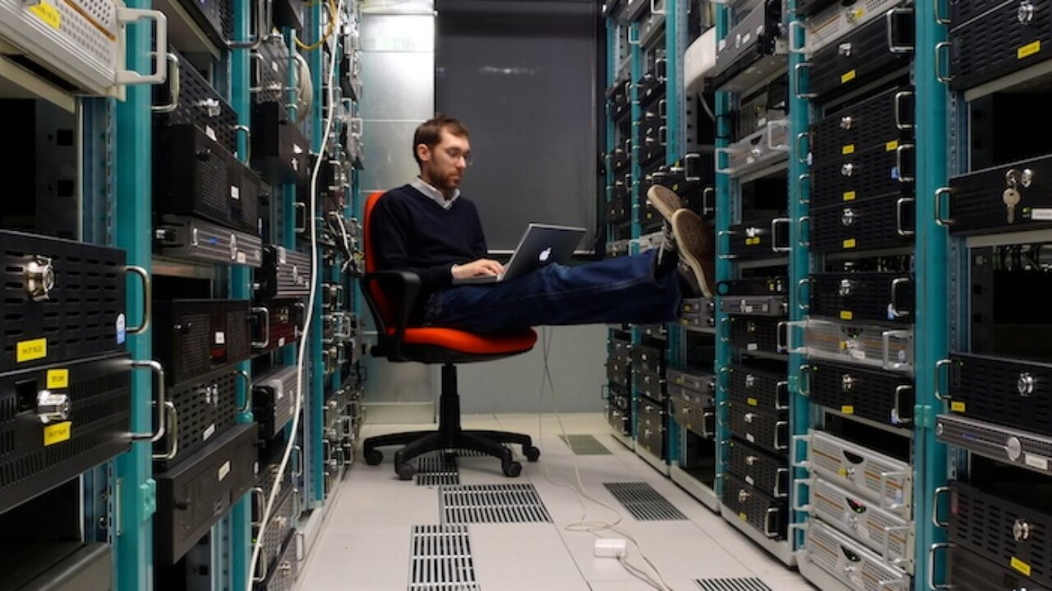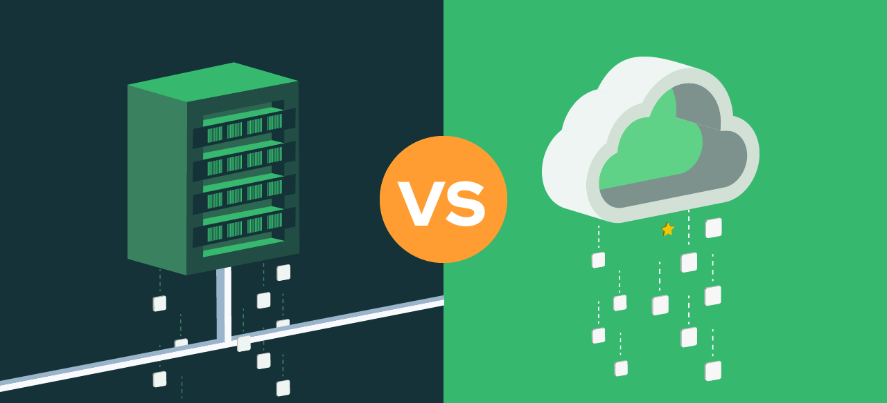

Assignment on Cloud Computing

ON-PREM VS CLOUD

Emmanuel Okose | DevOps | 7/August/2024

# **Cloud Computing**

Cloud computing is like renting a very efficient, sometimes world-class flexible workspace on the internet. Instead of buying and maintaining your own equipment, in this method of computing, you can use servers, storage, databases, and software provided by someone else. It is usually fast, flexible, and often cheaper.

**Key Features:**

1. **On-Demand Self-Service:**

* When you are needing more server power or storage space this model makes it possible for you to get them instantly, without asking anyone.

1. **Broad Network Access:**

* Whether you're on a phone, tablet, or laptop, you can access cloud services from anywhere that has an internet connection.

1. **Resource Pooling:**

* This is a very massive pool of resources. The cloud provider shares/allocates these resources to different customers as needed.

1. **Rapid Elasticity:**

* When you need more resources or need to reduce your resource usage (because you realize that you have allocated much resources to some applications than necessary), and you are operating on a cloud environment, you don’t need to panic in where and how to buy new servers, maintain them, install/setup, etc… simply log in to your cloud environment and scale as necessary.

1. **Measured Service:**

* This is a characteristic of the cloud that enable you to pay for what you use. You can configure your cloud usage to be metered and reported based on certain triggers (I,e setting alerts and creating reports).

**Service Models:**

1. **Infrastructure as a Service (IaaS):**

* In this category of service model. You are able to get the framework for your IT operations (i.e: virtual or physical machines and other resources).
* *Examples of services in this cadre are:* AWS EC2, Google Compute Engine.

1. **Platform as a Service (PaaS):**

* The cloud environment also have a service model that offers a platform to build, run, and manage applications? PaaS has you covered.
* *Examples:* Google App Engine, Microsoft Azure App Services, AWS Lambda, etc...

1. **Software as a Service (SaaS):**

* With cloud computing, you can be able to access software applications over the internet, this (on the most cases) is usually on a subscription basis.
* *Examples:* Google Workspace, Microsoft 365, Salesforce, Ilovepdf, etc...

# **On-Premises (On-Prem) Environments**

On-premises means all your computing resources are situated within you or your organization's physical location. You or your organization own and manage everything.

**Key Features:**

1. **Full Control:**

* You have complete control over hardware and software. Customize everything to your taste, in the way you want.

1. **Capital Expenditure (CapEx):**

* The initial amount of money required to set up this type of computing is usually heavy, and one needs to be ready for a big initial investment in hardware and infrastructure devices and installment.

1. **Maintenance and Management:**

* This characteristic of the On-prem model denotes that you oversee all the maintenance, updates, and security. This includes dealing with hardware failures and software patches.

1. **Data Proximity:**

* One of the perks of the on-prem model is that your data stays local Which means that the latency of communication is going to be very little, and this is great for applications that need quick access or apps that must meet data sovereignty rules.

1. **Scalability:**

* On-Prem is known to be limited by physical space and budget. Expanding means buying and setting up new hardware, which can take time to process and get ready for usage.

# **Differences Between Cloud and On-Prem**

|  |  |  |
| --- | --- | --- |
| ITEMS | CLOUD | ON-PREM |
| Cloud | Operates on a pay-as-you-go model with minimal upfront costs. But can still support full upfront payment if you wish. | Requires significant upfront investment in infrastructure. |
| Scalability and Flexibility | Easily Scalable. Can adjust resources up or down as needed. | Limited by physical space and budget. Scaling up takes time. |
| Maintenance and Management | Is managed by the service provider, this reduces your IT staff’s workload. | All management and maintenance are your responsibility. |
| Deployment Speed | Here, services and applications can be deployed quickly, often within minutes. | Longer deployment times due to the required physical setup and configuration. |
| Security | Security is managed by the provider, but you still need to secure your applications. | Full control over security rests on you, and you are also responsible for any breach(es). |
| Compliance | May require careful management to meet regulatory requirements. | Easier to ensure compliance, as you control all the data. |

# Advantages of On Premises Setup

These are some of the advantages of the On-Premises setup model of computing:

1. **Improved Performance and Latency:** With the infrastructure fully set-up within the location of the business that runs off of it, applications now experience shorter latency in communication thus boosting the overall performance.
2. **Cost Efficiency for Specific Use Cases** (E.g: For Large organizations like Government Scientific Research institutes that needs to be crunching/processing, storing and churning in-and-out large sums of data, the On-Prem model could be a more cost effective option for them in the long term compared to the cloud-based counterpart.
3. **Compliance and Regulatory Adherence**: highly regulated organizations e.g: Banks, hospitals, etc… would often prefer their infrastructure to be On-Prem in order to maintain strict control over their data and meet the compliance requirements.
4. **Complete Control and Ownership**: Organizations that are runs on an On-premises model usually retain full ownership and control over their hardware, software, and data. This usually provide greater flexibility in terms of customization and configuration.
5. **Enhanced Security:** With the On-Prem model, data stays within the organization’s physical-controlled-area. This reduces the risk of data breaches and unauthorized access compared to it’s cloud solution counterpart.